**If you observed the following:**

* burning sensation in the stomach
* burning sensation in the throat and heart
* difficulty in swallowing
* regurgitation
* restlessness
* belching
* nausea
* prolonged sour taste in the mouth
* bad breath
* indigestion
* constipation

you may be suffering from ACIDITY.

**ACIDITY** refers to a set of symptoms caused by an imbalance between the acid secreting mechanism of the stomach and proximal intestine and the protective mechanisms that ensure their safety. The stomach normally secretes acid that is essential in the digestive process. This acid helps in breaking down the food during digestion. When there is excess production of acid by the gastric glands of the stomach, it results in the condition known as acidity.

What is the cause of acidity in human body?

Both diarrhea and vomiting can cause this type of acidosis. Lactic acidosis occurs when there's too much lactic acid in your body. Causes can include chronic alcohol use, heart failure, cancer, seizures, liver failure, prolonged lack of oxygen, and low blood sugar.

**REMEDIES to cure ACIDITY:**

- Have a glass of lukewarm water every day.  
- Include banana, watermelon and cucumber in your daily diet.

- Coconut water is known to soothe the system if you suffer from acidity.  
- Drink a glass of milk - everyday.  
- Have your last meal at least two to three hours before you hit the sack.  
- Keeping long intervals between meals is another cause for acidity. Have small but regular meals.  
- Try to avoid pickles, spicy chutneys, vinegar, etc

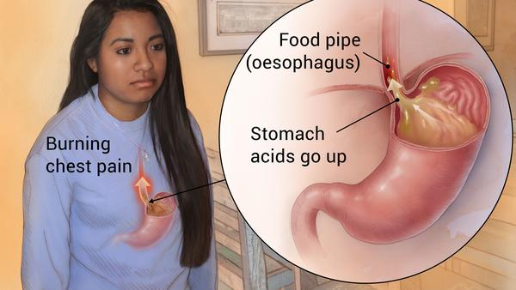 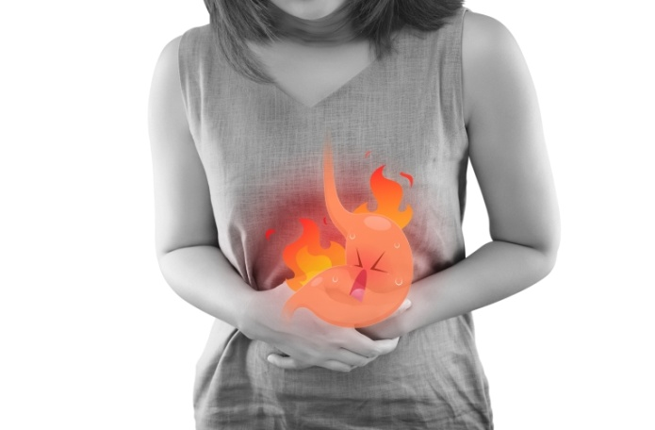

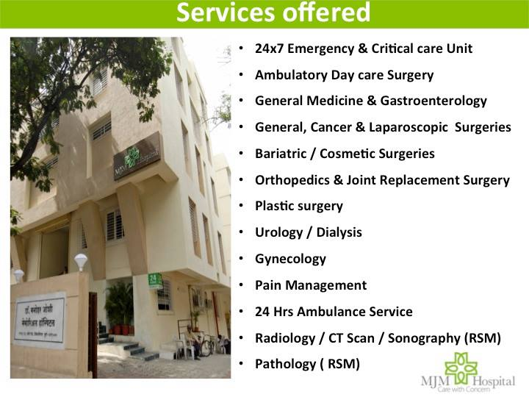 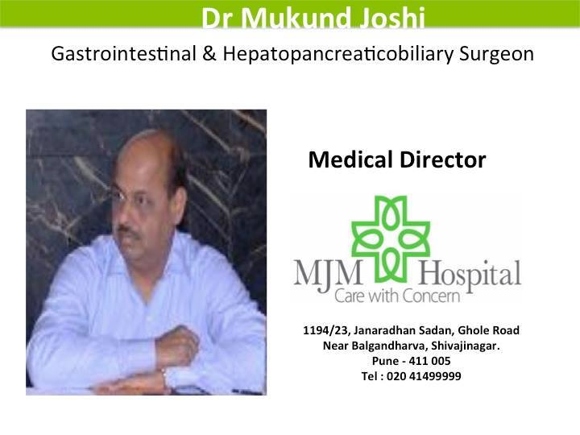

**MJM Hospital** runs **“ACIDITY CLINIC”** in their hospital at Ghole Road, PUNE. The hospital is instrumental in reducing **ACIDITY** problems in hundreds of patients.

For more details contact: 09769337236.